**Quiz-1 Algorithms section B, FALL 2016**

Q-1: Given mergesort, at each level j=0,1,2..logn, there are _________ subproblems each of size ___________. (recall the recursion tree of merge sort) **(2)**

Q-2: Give the time complexity T(n) of MERGE routine in merge sort. Show how it is a linear equation. **(4)**

Assume that from p to r, there are n numbers.

Q-3: Below is the pseudocode of bubblesort: **(4)**

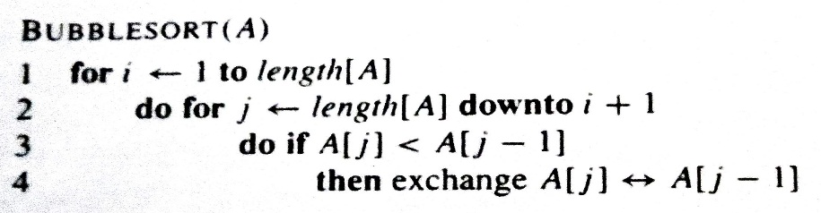

Show each iteration of the pseudocode on an input array of [4 6 1 5 2]. Clearly show the pointers i and j at each iteration.